Microsoft guide for My Site: <http://technet.microsoft.com/en-us/library/ee624362.aspx>

**Setup for SharePoint My Profile + My Site**

**Add managed path to the Web application**

Central Admin >[Application Management](http://evadne7:17076/applications.aspx) > Manage web application

-Highlight the port 80 web application and click managed paths

-now add “my” and “my/personal” path to it.

Path: my Type: explicit Path: my/personal Type: wildcard

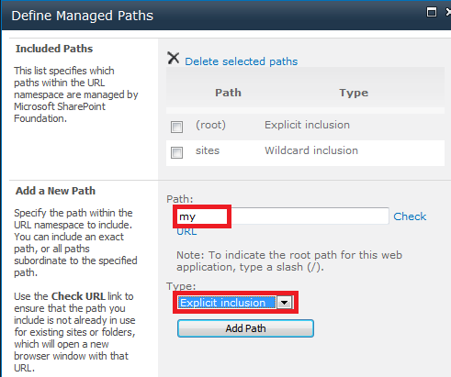 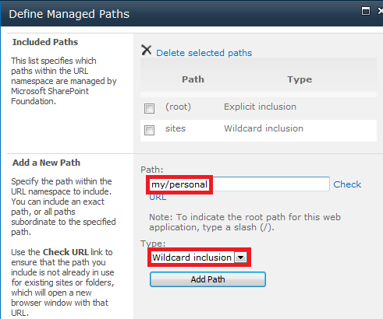

**create a new site collection for My Site Host**

Central Admin >[Application Management](http://evadne7:17076/applications.aspx) > Create site collections

Select your port 80 web application

Title: My Site

Url: select /my

Template: select “My Site Host” under enterprise tab

User Name: system

Click OK

**enable self-service site creation for the Web application**

done this in to Web Service setup. skip it

if not then refer to Web Service.docx

**create a site collection for search**

Central Admin >[Application Management](http://evadne7:17076/applications.aspx) > Create site collections

Select your port 80 web application

Title: Search

Url: select [/my/personal/Search](javascript:__doPostBack('ctl00$PlaceHolderMain$GvItems','Select$6'))

Template: select “enterprise search center” under enterprise tab

User Name: system

Click OK

**Configure My Site settings under the User Profile service application**

Central Admin >Application Management >Manage service applications >User Profile Service Application> Setup My Sites

-Follow the picture below and change to your own server.

